What is a parser?
In computer technology, a parser is a program that's usually part of a compiler. It receives input in the form of sequential source program instructions, interactive online commands, markup tags or some other defined interface.
Parsers break the input they get into parts such as the nouns (objects), verbs (methods), and their attributes or options. These are then managed by other programming, such as other components in a compiler. A parser may also check to ensure that all the necessary input has been provided.

How does parsing work?
A parser is a program that is part of the compiler, and parsing is part of the compiling process. Parsing happens during the analysis stage of compilation.
In parsing, code is taken from the preprocessor, broken into smaller pieces and analyzed so other software can understand it. The parser does this by building a data structure out of the pieces of input.
More specifically, a person writes code in a human-readable language like C++ or Java and saves it as a series of text files. The parser takes those text files as input and breaks them down so they can be translated on the target platform.
The parser consists of three components, each of which handles a different stage of the parsing process. The three stages are:

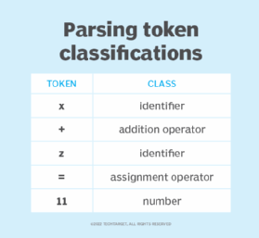
Given the set of characters x+z=11, the lexical analyzer would separate it into a series of tokens and classify them as shown.

Stage 1: Lexical analysis
A lexical analyzer -- or scanner -- takes code from the preprocessor and breaks it into smaller pieces. It groups the input code into sequences of characters called lexemes, each of which corresponds to a token. Tokens are units of grammar in the programming language that the compiler understands.

What is a token?
In general, a token is an object that represents something else, such as another object (either physical or virtual), or an abstract concept as, for example, a gift is sometimes referred to as a token of the giver's esteem for the recipient. In computers, there are a number of types of tokens

Programming token
A programming token is the basic component of source code. Characters are categorized as one of five classes of tokens that describe their functions
(constants, identifiers, operators, reserved words, and separators)
in accordance with the rules of the programming language.
Identifier: Identifiers are used to name a variable, constant, function, class, and array. It usually defined by the user. It uses letters, underscores, or a dollar sign as the first character.
Remember that the identifier name must be different from the reserved keywords. There are some rules to declare identifiers are:

Literals: In programming literal is a notation that represents a fixed value (constant) in the source code. It can be categorized as an integer literal, string literal, Boolean literal, etc. It is defined by the programmer. Once it has been defined cannot be changed. Java provides five types of literals are as follows:
- Integer
- Floating Point
- Character
- String
- Boolean
separator <= ; | , | . | ( | ) | { | } | [ | ]

Security token
A security token is a physical device, such as a special smart card, that together with something that a user knows, such as a PIN, will enable authorized access to a computer system or network.

Lexical analyzers also remove white space characters, comments and errors from the input.

Stage 2: Syntactic analysis
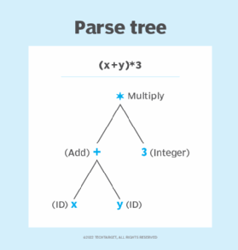
The syntactic analyzer takes (x+y)*3 as input and returns this parse tree, which enables the parser to understand the equation.
This stage of parsing checks the syntactical structure of the input, using a data structure called a parse tree or derivation tree. A syntax analyzer uses tokens to construct a parse tree that combines the predefined grammar of the programming language with the tokens of the input string. The syntactic analyzer reports a syntax error if the syntax is incorrect.

Stage 3: Semantic analysis
Semantic analysis verifies the parse tree against a symbol table and determines whether it is semantically consistent. This process is also known as context sensitive analysis. It includes data type checking, label checking and flow control checking.
If the code provided is this:
float a = 30.2; float b = a*20
then the analyzer will treat 20 as 20.0 before performing the operation.
Some sources refer only to the syntactic analysis stage as parsing because it generates the parse tree. They leave out lexical and semantic analysis.
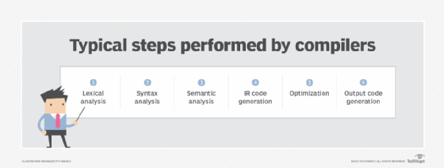
Parsing occurs in the first three stages of the compilation process -- lexical, syntax and semantic analysis.

What are the main types of parsers?
When a software language is created, its creators must specify a set of rules. These rules provide the grammar needed to construct valid statements in the language.
The following is a set of grammatical rules for a simple fictional language that only contains a few words:
<sentence> ::= <subject> <verb> <object>
<subject> ::= <article> <noun>
<article> ::= the | a
<noun> ::= dog | cat | person
<verb> ::= pets | fed
<object> ::= <article> <noun>
In this language, a sentence must contain a subject, verb and noun in that order, and specific words are matched to the parts of speech. A subject is an article followed by a noun. A noun can be one of the following three words: dog, cat or person. And a verb can only be pets or fed.
Parsing checks a statement that a user provides as input against these rules to prove that the statement is valid. Different parsing algorithms check in different orders. There are two main types of parsers:
- Top-down parsers. These start with a rule at the top, such as <sentence> ::= <subject> <verb> <object>. Given the input string "The person fed a cat," the parser would look at the first rule, and work its way down all the rules checking to make sure they are correct. In this case, the first word is a <subject>, it follows the subject rule, and the parser will continue reading the sentence looking for a <verb>.
- Bottom-up parsers. These start with the rule at the bottom. In this case, the parser would look for an <object> first, then look for a <verb> next and so on.
More simply put, top-down parsers begin their work at the start symbol of the grammar at the top of the parse tree. They then work their way down from the rule to the sentence. Bottom-up parsers work their way up from the sentence to the rule.

What technologies use parsing?
Parsers are used when there is a need to represent input data from source code abstractly as a data structure so that it can be checked for the correct syntax. Coding languages and other technologies use parsing of some type for this purpose.
Technologies that use parsing to check code inputs include the following:

Database languages. Database languages such as Structured Query Language also use parsers.
Markup languages – http, css
Protocols. Protocols like the Hypertext Transfer Protocol and internet remote function calls use parsers.
Parser generator. Parser generators take grammar as input and generate source code, which is parsing in reverse. They construct parsers from regular expressions, which are special strings used to manage and match patterns in text.

Data parsing

What is data parsing?
Data parsing is a widely used method for data structuring;
Data parsing is a method where one string of data gets converted into a different type of data. So let’s say you receive your data in raw HTML, a parser will take the said HTML and transform it into a more readable data format that can be easily read and understood.

What is data scraping?
Data scraping is the process of acquiring large amounts of data from the web through the use of automation and rotating IP address.

What is Serialization?
Serialization is the process in which one service takes in a data structure, such as a dictionary in Python, wraps it up, and transmits it to another service for reading. That’s the simple definition.
Imagine that I need to send a message to someone. So I write down the text on an already assembled puzzle. I take apart the pieces, add some instructions on how to reassemble the puzzle, and send it along.
The message recipient then gets the pieces of the puzzle, puts them all back together, and now they have my message.
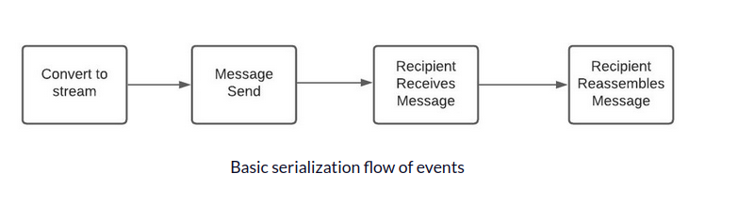

The technical definition is a bit more fun. To wit, serialization is the process of converting a data object into a byte stream, and saving the state of the object to be stored on a disk or transmitted across a network. This cuts down the storage size needed and makes it easier to transfer information over a network.

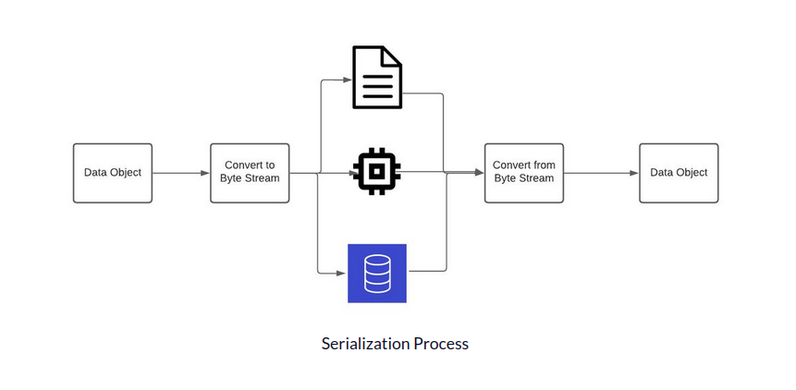

Marshaling and Serialization - what are the differences?
The process of marshaling might come to mind. Marshaling is the process of transforming the memory representation of an object into a suitable form for transmission.
Although marshaling and serialization are loosely synonymous, there is a crucial difference. For example, when creating a Golang program to read JSON data into a Golang data structure, you might use marshaling to translate JSON key values into Golang key values.
The difference is that marshaling might be used to translate data. In contrast, serialization sends or stores data in a byte stream and reassembles it in its original form. Both do serialization, but there is a difference in intent in these two processes.

Serialization encodes objects into another format.
For example you have an array in PHP like this:
$array = array("a" => 1, "b" => 2, "c" => array("a" => 1, "b" => 2));
And then you want to store it in file or send to other application.
There are several format choices, but the idea is the same: The array has to be encoded (or you could say "translated"), into text or bytes, that can be written to a file or sent via the network.
For example, in PHP, if you:
$data = serialize($array);
you will get this:
a:3:{s:1:"a";i:1;s:1:"b";i:2;s:1:"c";a:2:{s:1:"a";i:1;s:1:"b";i:2;}}
This is PHP's particular serializing format that PHP understands, and it works vice versa, so you are able to use it to deserialize objects.
For example, you stored a serialized array in a file, and you want it back in your code as an array:
$array = unserialize($data);
But you could choose a different serialization format, for example, JSON:
$json = json_encode($array);
will give you this:
{"a":1,"b":2,"c":{"a":1,"b":2}}
The result is not only easily saved, read by human eye, or sent via network, but is also understandable by almost every other language (JavaScript, Java, C#, C++, ...)

Conclusion
Serialization translate objects to another format, in case you want to store or share data.
Are there any situations, where you cannot do anything, but serialize it?
No. But serialization usually makes things easier.
Are JSON and PHP format the only possible formats?
No, no, no and one more time no. There are plenty of formats.
- XML (e.g. using a schema like WSDL or XHTML)
- Bytes, Protobuf, etc.
- Yaml
- ...
- ...
- Your own formats (you can create your own format for serialization and use it, but that is a big thing to do and is not worth it, most of the time)

Serialize JSON means:
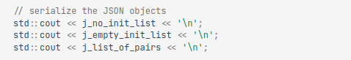

JSON

JSON stands for JavaScript Object Notation
JSON is a text format for storing and transporting data
JSON is "self-describing" and easy to understand

What is JSON Data?
The JSON data is represented in the form of key-value pairs. This is similar to a dictionary or hash in other programming languages.

JSON Object Example
A JSON object contains data in the form of key/value pair. The keys are strings and the values are the JSON types. Keys and values are separated by colon. Each entry (key/value pair) is separated by comma.

person = {name:"John", age:31, city:"New York"};

// returns John
person.name;

// returns John
person["name"];

Data can be modified like this:

Example
person.name = "Gilbert";

It defines an object with 3 properties:
- name
- age
- car
Each property has a value.
If you parse the JSON string with a JavaScript program, you can access the data as an object:
let personName = obj.name;
let personAge = obj.age;

Why Use JSON?
The JSON format is syntactically similar to the code for creating JavaScript objects. Because of this, a JavaScript program can easily convert JSON data into JavaScript objects.
Since the format is text only, JSON data can easily be sent between computers, and used by any programming language.

What is JSON?
- JSON stands for JavaScript Object Notation
- JSON is a lightweight data-interchange format
- JSON is plain text written in JavaScript object notation
- JSON is used to send data between computers
- JSON is language independent *

JSON is Like XML Because
- Both JSON and XML are "self describing" (human readable)
- Both JSON and XML are hierarchical (values within values)
- Both JSON and XML can be parsed and used by lots of programming languages
- Both JSON and XML can be fetched with an XMLHttpRequest

JSON is Unlike XML Because
- JSON doesn't use end tag
- JSON is shorter
- JSON is quicker to read and write
- JSON can use arrays
The biggest difference is:
XML has to be parsed with an XML parser. JSON can be parsed by a standard JavaScript function.

Why JSON is Better Than XML
XML is much more difficult to parse than JSON.
JSON is parsed into a ready-to-use JavaScript object.

Json serializing
JSON is a format that encodes objects in a string. Serialization means to convert an object into that string, and deserialization is its inverse operation (convert string -> object).

How do I serialize a JSON file?

To write JSON to a string or to a file, call the JsonSerializer. Serialize method. The JSON output is minified (whitespace, indentation, and new-line characters are removed) by default

SQLite
What is SQLite and how does it work?

SQLite is a software library that translates high-level disk I/O requests generated by an application into low-level I/O operations that can be carried out by the operating system. The application constructs high-level I/O requests using the SQL language.

What is difference between SQL and SQLite?

SQLite is an Relational Database Management System which is written in ANSI-C. SQL is standard which specifies how relational schema is created, data is inserted or updated in relations, transactions are started and stopped, etc. SQLite is file-based

Is SQLite and MySQL same?

MySQL uses a database server to run on a network, which can then be accessed by the client. SQLite, however, is what is known as an embedded database. This means that the structure is stored on the application itself

MySQL has a well-constructed user management system which can handle multiple users and grant various levels of permission. SQLite is suitable for smaller databases. As the database grows the memory requirement also gets larger while using SQLite. Performance optimization is harder when using SQLite.

Is SQLite a local database?

It's local to the phone. If you need it accessed else where you need to use a web server and upload it to there.

Is SQLite faster than SQL Server?

SQLite is generally a lot faster than SQL Server. However, SQLite only supports a single writer at a time (meaning the execution of an individual transaction). SQLite locks the entire database when it needs a lock (either read or write) and only one writer can hold a write lock at a time

SQLite is self-contained means it requires minimal support from the operating system or external library. This makes SQLite usable in any environment especially in embedded devices like iPhones, Android phones, game consoles, handheld media players, etc.

Introduction to the command line

ls-
The ls command is used to list files. "ls" on its own lists all files in the current directory except for hidden files.

Mkdir

ake directory
The mkdir command in Linux/Unix allows users to create or make new directories. mkdir stands for “make directory.” With mkdir , you can also set permissions, create multiple directories (folders) at once, and much more

kdir command in Linux allows the user to create directories (also referred to as folders in some operating systems

pwd or print working directory
The pwd command prints out the current directory you are in. What are directories? Directories are folders, these terms are used interchangeably. If you just opened up your terminal, you are probably in the home directory of your computer, and should get an output similar to this:

ls or list
In your terminal type:
$ ls
and hit enter. Most likely this command returned you a bunch of files and folders. The ls command prints out the contents of a directory. If you are in the home directory of your computer you should see directories printed out such as Documents, Applications, etc. Now, how do you move across directories?

cd or change directory
The cd command allows you to move between directories. The cd command takes an argument, usually the name of the folder you want to move to, so the full command is cd your-directory.
In the terminal, type:
$ ls
Let’s say we wanted to move to the Desktop folder: just type in your terminal
$ cd Desktop
Now type:
$ pwd
This should return you something like:
/Users/your-username/Desktop
Now that we moved to your Desktop, you can type ls again, then cd into it. We have just changed into a new directory. You can use these two commands to navigate around your computer.
This is all good so far, but sometimes you might want to go deeper than one level in one command. cd allows you to do this by chaining the directories with a /, so cd your-directory becomes cd your-directory/directory-inside-your-directory.
We now know how to move forward. But how to go back up the directory tree? Type in your terminal:
$ cd ..
Now do a pwd. You just went back one directory! Chaining works backwards too, so if you type cd ../.. you should be taken back two directories.

On a Windows system, if you want to use a different text editor, you must specify the full path to its executable file. This can be different depending on how your editor is packaged.

Version control this project. From within the project directory run the command git init. This will create a .git directory and set you up to start version control.

Git commands
git init
git status -m
git config --global user.name "YOUR_USERNAME"
git config --global user.email "im_satoshi@musk.com"
git config --global --list # To check the info you just provided
git add “filename.txt”
git status
git commit -m “comments”
git log
git branch

git reset HEAD~1
# Remove the most recent commit
# Commit again!

Add a remote origin and Push:
Now each time you make changes in your files and save it, it won’t be automatically updated on GitHub. All the changes we made in the file are updated in the local repository. Now to update the changes to the master:

$ git remote add origin remote_repository_URL
# sets the new remote
The git remote command lets you create, view, and delete connections to other repositories.

$ git remote -v
# List the remote connections you have to other repositories.
The git remote -v command lists the URLs of the remote connections you have to other repositories.

$ git push -u origin master # pushes changes to origin
Now the git push command pushes the changes in your local repository up to the remote repository you specified as the origin.

See the Changes you made to your file:
Once you start making changes on your files and you save them, the file won’t match the last version that was committed to git. To see the changes you just made:
$ git diff # To show the files changes not yet staged

Revert back to the last committed version to the Git Repo:
Now you can choose to revert back to the last committed version by entering:
$ git checkout .

OR for a specific file

$ git checkout -- <filename>

View Commit History:
You can use the git log command to see the history of commit you made to your files:
$ git log

Each time you make changes that you want to be reflected on GitHub, the following are the most common flow of commands:
$ git add .
$ git status # Lists all new or modified files to be committed
$ git commit -m "Second commit"
$ git push -u origin master

To store the credentials:
In addition to user701648's answer, you can store your credentials in your home folder (global for all projects), instead of project folder using the following command
$ git config --global credential.helper store
$ git push http://example.com/repo.git
Username: <type your username>
Password: <type your password>

Step 5 : That’s all well and good… But How do I download and work on other repositories on GitHub?

Cloning a Git Repo:
Locate to the directory you want to clone the repo. Copy the link of the repository you want and enter the following:
$ git clone remote_repository_URL

Pushing Changes to the Git Repo:
Now you can work on the files you want and commit to changes locally. If you want to push changes to that repository you either have to be added as a collaborator for the repository or you have create something known as pull request. Go and check out how to do one here and give me a pull request with your code file.

Collaborating:
So imagine you and your friend are collaborating on a project. You both are working on the same project files. Each time you make some changes and push it into the master repo, your friend has to pull the changes that you pushed into the git repo. Meaning to make sure you’re working on the latest version of the git repo each time you start working, a git pull command is the way to go.
So to make sure those changes are reflected on my local copy of the repo:
$ git pull origin master

Here’s two more useful git commands:
$ git fetch
AND
$ git merge
In the simplest terms, git fetch followed by a git merge equals a git pull. But then why do these exist?
When you use git pull, Git tries to automatically do your work for you. It is context sensitive, so Git will merge any pulled commits into the branch you are currently working in. git pull automatically merges the commits without letting you review them first.
When you git fetch, Git gathers any commits from the target branch that do not exist in your current branch and stores them in your local repository. However, it does not merge them with your current branch. This is particularly useful if you need to keep your repository up to date, but are working on something that might break if you update your files. To integrate the commits into your master branch, you use git merge.

